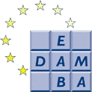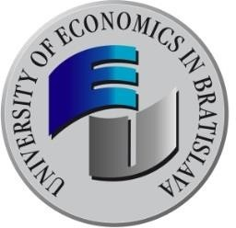

PROGRAMME
EDAMBA 2019 EMPOWERING ACTIONS TO ACHIEVE GOALS: IMPLICATIONS FOR ECONOMICS, BUSINESS, MANAGEMENT AND RELATED DISCIPLINES
22nd International Scientific Conference for Doctoral Students and Post-Doctoral Scholars
University of Economics in Bratislava, 23rd – 24th October 2019

EDAMBA 2019 INTERNATIONAL SCIENTIFIC COMMITTEE

Ferdinand DAŇO, Rector of the University of Economics in Bratislava, Slovak Republic
Adina BARBULESCU, West University of Timisoara, Romania Alexandru BURIAN, European University of Moldova, Moldova Petr FIALA, University of Economics, Prague, Czech Republic Véronique FLAMBARD, Université Catholique de Lille, France Sujit CHAUDHURI, University of Physical Education, Budapest, Hungary
Josef JABLONSKÝ, University of Economics, Prague, Czech Republic
Bhavish JUGURNATH, University of Mauritius, Mauritius Miroslav KARLÍČEK, University of Economics, Prague, Czech Republic
Larisa KAPUSTINA, Ural State University of Economics, Yekaterinburg, Russian Federation,
Lidiia KARPENKO, National Academy for Public Administration, Odessa, Russian Federation,
Ricardo MORAIS, Catholic University in Porto, Portugal Mykola MYKHAILOVYCH PALINCHAK, Uzhhorod National University, Ukraine
Michele PAOLINI, Comenius University in Bratislava, Slovak Republic
Mária REŽŇÁKOVÁ, Masaryk University, Brno, Czech Republic,
Boopen SEETANAH, University of Mauritius, Mauritius
Hema SOONDRAM, University of Mauritius, Réduit, Mauritius
Elias SOUKIAZIS, University of Coimbra, Portugal
František SUDZINA, Aalborg University, Denmark
Petr SUCHÁNEK, Masaryk University, Brno, Czech Republic
Cosmin TILEAGĂ, University „Lucian Blaga“ Sibiu, Romania Michael TWUM-DARKO, Cape Peninsula University of Technology, South Africa
Troy WIWCZAROSKI, University of Debrecen, Hungary
Irena ZAVRL, Fachhochschule Burgenland, Eisenstadt, Austria

EDAMBA 2019 PROGRAMME COMMITTEE

Paula Puškárová, University of Economics in Bratislava, Slovak Republic,

Marcel Novák, Faculty of National Economy, University of Economics in Bratislava, Slovak Republic,

Róbert Rehák, Faculty of Commerce, University of Economics in Bratislava, Slovak Republic,

Erik Šoltés, Faculty of Economic Informatics, University of Economics in Bratislava, Slovak Republic,

Miroslav Tóth, Faculty of Business Management, University of Economics in Bratislava, Slovak Republic,

Ľudmila Lipková, Faculty of International Relations, University of Economics in Bratislava, Slovak Republic,

Emília Duľová-Spišáková, Faculty of Business Economy with seat in Košice, University of Economics in Bratislava, Slovak Republic,

Mária Spišiaková, Faculty of Applied Languages, University of Economics in Bratislava, Slovak Republic,

EDAMBA 2019 ORGANISING COMMITTEE
Gabriel ADAMEK, Department for Research and Doctoral Studies, University of Economics in Bratislava Andrea PETIANOVÁ, Department for Research and Doctoral Studies, University of Economics in Bratislava Jana TKÁČOVÁ, Department for Research and Doctoral Studies, University of Economics in Bratislava

MAP OF THE BRATISLAVA CAMPUS AND THE CONFERENCE VENUE

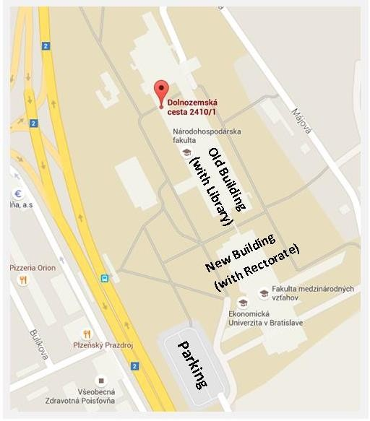
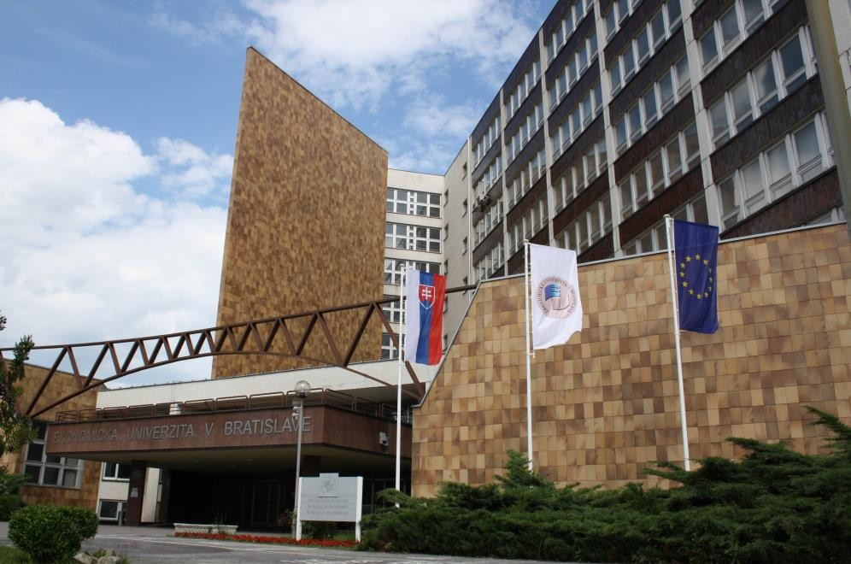
MAIN ENTRANCE - NEW BUILDING (WITH RECTORATE)

BRATISLAVA CAMPUS: INTERDISCIPLINARY CONFERENCE SESSIONS - THEMES

Economic Theory 1, Bratislava Campus: Room D117 - Old Building (with Library), Ground Floor
Economic Theory 2, Bratislava Campus: Room 1C.02 - Old Building, 1st Floor
Marketing, Bratislava Campus: Room 1B.02 - Old Building, 1st Floor
Accounting & Business & Informatics, Bratislava Campus: Room A7.12 - New Building (with Rectorate), 7th Floor
Financial Management, Bratislava Campus: Room A6.04 - New Building (with Rectorate), 6th Floor
Global Economics & Language, Bratislava Campus: Room A4.04 - New Building (with Rectorate), 4th Floor

CONFERENCE PROGRAMME OVERVIEW

Wednesday – 23rd October 2019
Day 1: EMPOWERING ACTIONS TO ACHIEVE GOALS:
IMPLICATIONS FOR ECONOMICS, BUSINESS, MANAGEMENT AND RELATED DISCIPLINES
08:00 - 09:00 | Registration of participants  Bratislava Campus: Conference Room, New Building (with Rectorate), 3rd Floor
09:00 - 09:15 | Opening of the conference  Ferdinand DAŇO, Rector of the University of Economics in Bratislava  Bratislava Campus: Conference Room, New Building (with Rectorate), 3rd Floor
09:15 - 10:00 | Plenary Session  Silvester van KOTEN: Energy Economics and Experimental Economics  Bratislava Campus: Conference Room, New Building (with Rectorate), 3rd Floor
10:00 – 10:45 | Plenary Session  Alexandru MINEA: Public Debt and Economic Growth  Bratislava Campus: Conference Room, New Building (with Rectorate), 3rd Floor
10:45 - 11:00 | Coffee break
11:00 - 12:15 | Project Management Seminar chair: Gabriela DUBCOVÁ  Bratislava Campus: Conference Room, New Building (with Rectorate), 3rd Floor
12:15 - 13:30 | Lunch
13:30 – 16.45 | Presentation of participants’ papers in parallel sessions and informal networking II. Economic Theory 1, Bratislava Campus: Room D117 - Old Building (with Library), Ground Floor Economic Theory 2, Bratislava Campus: Room 1C.02 - Old Building, 1st Floor  Marketing, Bratislava Campus: Room 1B.02 - Old Building, 1st Floor  Accounting & Business & Informatics, Bratislava Campus: Room A7.12 - New Building (with Rectorate), 7th Floor  Financial Management, Bratislava Campus: Room A6.04 - New Building (with Rectorate), 6th Floor  Global Economics & Language, Bratislava Campus: Room A4.04 - New Building (with Rectorate), 4th Floor

CONFERENCE PROGRAMME OVERVIEW

Thursday – 24th October 2019
Day 2: EMPOWERING ACTIONS TO ACHIEVE GOALS:
IMPLICATIONS FOR ECONOMICS, BUSINESS, MANAGEMENT AND RELATED DISCIPLINES
09:30 - 11:00 | Fulbright Brunch – Meet & Greet w/Fulbright Commission, SFAA & US Embassy  Bratislava Campus: Conference Room, New Building (with Rectorate), 3rd Floor
11:00 – 12:15 | Plenary Session  Edouard TURKISCH: Fiscal rules and fiscal outcomes in the EU  Bratislava Campus: Conference Room, New Building (with Rectorate), 3rd Floor
12:15 – 12:30 | Best Paper Award & Closing the conference Paula Puškárová, Vice-rector for research and doctoral studies,  Bratislava Campus: Conference Room, New Building (with Rectorate), 3rd Floor
12:30 - 13:30 | Lunch

PLENARY SESSION: Project Management Seminar
BRATISLAVA CAMPUS: CONFERENCE ROOM, New Building (with Rectorate), 3rd Floor

Wednesday – 23rd October 2019
11:00 - 12:15 | EUBA Grant Scheme for Young Scholars and Doctoral Students  Paula PUŠKÁROVÁ, University of Economics in Bratislava
SAIA for Young Scholars and Doctoral Students

Kristína SALLEROVÁ / Adela POLÁČKOVÁ
National Scholarship Program

Richard KALIŠ, Faculty of National Economy, University of Economics in Bratislava
Action Austria-Slovakia

Erika MAJZLÍKOVÁ, Faculty of National Economy, University of Economics in Bratislava
Horizon 2020 – Twinning proposal

Paula PUŠKÁROVÁ, University of Economics in Bratislava
 | Discussion

SESSION 1 - ECONOMIC THEORY 1

BRATISLAVA CAMPUS: ROOM D117, Old Building (with Library), Ground Floor

Wednesday – 23rd October 2019
13:30 – 16:45 | Lukáš BURIAN:  Further fiscal integration in euro area
Igor DVORNICKÝ:
Changes in the indicators of credit and financial market assessments in terms of Macroprudential policy
Raman HERASIMAU:
Does pension systems have future
Miroslav KLIMEK:
Creation of an equity portfolio @ EUBA 2019
Peter KUŠNÍR and Denis MATUŠOVIČ:
Company Valuation (Selected Theoretical Approaches)
Boris FIŠERA:
Impact of Managed Depreciations on Financial Markets
Peter GOLHA:
Stress Testing in the Context of Economic Cycle
Ionela OPREA:
Leading practices in sustainable banking
Tatiana SERGIENKO:
SOCIO-ECONOMIC COMPONENTS OF THE INTEGRATION POLICY OF MODERN UKRAINIAN SOCIETY IN THE CONDITIONS OF INFORMATION-PSYCHOLOGICAL WARFARE
Jaroslava ŠEPEĽOVÁ:
Theoretical approaches of factors of tax evasion focused on accounting as a source of information in the tax´s liability calculation
Patrik JANKOVIČ:
Mobile Internet before Fifth Generation Cellular Systems (5G)(Determinants of Internet Coverage and Its Quality)

SESSION 1 - ECONOMIC THEORY 2

BRATISLAVA CAMPUS: ROOM 1C.02, Old Building, 1st Floor

Wednesday – 23rd October 2019
13:30 – 16:45 | Erika MAJZLÍKOVÁ:  Structural Decomposition Analysis of Changes in Manufacturing Employment in Slovakia
Eva SIRAKOVOVÁ:
Group Size Effects in Public Good Game
Matej VITÁLOŠ:
Susceptibility of Jobs to Automation in Slovakia
Zuzana KOŠŤÁLOVÁ:
Exploring driving forces of household debt in Slovakia
Agáta ŠULÁKOVÁ:
Synchronization of business cycles between selected European countries
Miriama TREBICHALSKÁ:
Social partnership and employment change due to the digital revolution
Adriana NOVOTNÁ:
Measuring competition in the European banking sector
Katarína MERTANOVÁ:
Does Slovak economy pull migrants toward it?
Peter MANDŽÁK:
Can money buy health? DEA analysis of healthcare expenditure
Lucia ORSZÁGHOVÁ:
Swiss Franc Lending in Central, Eastern and South Eastern Europe
Tetyana NESTORENKO:
Economic impact of health resort enterprises for the host city: case study from Ukraine

SESSION 2 – ACCOUNTING – BUSINESS INFORMATICS

BRATISLAVA CAMPUS: ROOM A7.12, New Building (with Rectorate), 7th Floor

Wednesday – 23rd October 2019
13:30 – 16:45 | Nikoleta BALOGHOVÁ:  Hidden reserves in financial management
Dana FIGUROVÁ:
Hidden reserves in financial management
Allan Jose SEGUEIRA LOPEZ:
Spatial Competition with Considering the Weight of the Nodes Case Study
Milan GEDEON:
The impact of new technologies on accounting and audit
Silvia ZELINOVÁ:
Statistical analysis of European Union countries on the basis of main Economic Indicators
Marek STREŽO:
Flexible regression modeling of the pure premium using Generalized Additive Models with Isotropic smoothing
Jana KOPČÁKOVÁ:
Assets and modern methods of depreciation of assets in an enterprise
Petra SRNIŠOVÁ:
Information on adopted accounting policies in the notes to the financial statements
Stanislav KOVÁČ:
Bitcoin volatility analysis: deterministic and probabilistic approach
Tatiana KATKOVA, Hana ALIEKSIEIEVA, Larysa HORBATIUK, Nataliia KRAVCHENKO:
Mathematical Methods for Assessing the Financial Condition of an Enterprise and Diagnosing Bankruptcy

SESSION 3 – FINANCIAL MANAGEMENT

BRATISLAVA CAMPUS: ROOM A6.04, New Building (with Rectorate), 6th Floor

Wednesday – 23rd October 2019
13:30 – 16:45 | Eva BIKÁROVÁ:  Environmental Problems and Developing Countries
Branislav KOVÁČ:
Contributions to other capital funds as the form of financing for businesses through own funds (equity) - legal, accounting and tax aspects
Zuzana JAKUBOVÁ:
Financing of family businesses
Daniela NEMCOVÁ:
Reconciling Social and Economic Needs into Ecological Society
Zuzana SKORKOVÁ:
Is Holacracy Bringing Down Hierarchy or Is It Only an Appealing Marketing Slogan?
Zuzana RUDAŠOVÁ:
Analysis of Treasury benchmarked bonds in primary market
Darina MÓŽIOVÁ:
Emerging types of business risks in insurance industry
Marian TOMAN:
The Corporate Challenges of Sustainable Development
Andrea LUKAČKOVÁ:
Prediction of the failure of the enterprise through rating models created in Slovak market conditions
Petra POLEČOVÁ:
Venture capital as a source of financing for enterprises in Slovakia

SESSION 4 – GLOBAL ECONOMICS & LANGUAGE
BRATISLAVA CAMPUS: ROOM A4.04, New Building (with Rectorate), 4th Floor

Wednesday – 23rd October 2019
13:30 – 16:45 | Natália GODA:  Soft power 30 index – Comparation of the Visegrad Group countries
Katarína ŽAMBOROVÁ:
Issues of International Educational Assessment in the Business Environment. The Slovak Republic.
Natalia BARINKOVÁ:
Foreign Trade Cooperation of Slovakia with Kazakhstan and Kyrgyzstan and Opportunities for Slovak Exporters
Jana KOZÁKOVÁ:
Encouragement of Entrepreneurial Talent in the Process of Entrepreneurship Education at Slovak University of Agriculture in Nitra: A Focus Group Study
Tatiana HAJNIKOVÁ:
Comparability analysis – the cornerstone of transfer pricing
Kristína KRUPOVÁ:
The rise of Islamic feminism in the contemporary milieu of international relations
Monika KOCHAJDOVÁ:
RUSSIA´S IMPLEMENTATION OF HYBRID WARFARE
Martin KARAS:
Investment Law in the Theory of International Relations
Ivana DANCÁKOVÁ:
Shaping migration tendencies in Europe
Viktória ŠVARDOVÁ:
Automation in Japan
Ondrej TOMČÍK:
EU-South Korea Free Trade Agreement and its impact on Slovakia’s exports to South Korea
Zuzana BOROVSKÁ:
Iran as an EU trading partner in a period of the current tense trade-political relations

SESSION 5 – MARKETING
BRATISLAVA CAMPUS: ROOM 1B.02, Old Building, 1st Floor

Wednesday – 23rd October 2019
13:30 – 16:45 | Jozef GÁLL:  Determining the significance level of tourist regions in Slovak Republic by cluster analysis
Elena CHUKURNA:
MARKETING EMOTIONS IN THE RESTAURANT BUSINESS
Peter BELIČKA:
New marketing segment: streaming platforms and event streaming
Marian ČVIRIK and Monika STANKOVÁ:
Relationship between Worldmindedness and Consumer ethnocentrism: A Case of Slovakia
Ivan HlAVATÝ:
Identification of knowledge management implementation barriers at Slovak higher education institutions
Yulia STAVSKA:
The role of marketing tools in managing unstable systems
Petra GARASOVÁ:
Consumer Perception of Eco-design
Denisa ŠEVČÍKOVÁ:
Predictors of success of a new product on the market
Alexander FRASCH:
Economic impacts of Boeing aircraft groundings on international markets
Romana ŠIPOLDOVÁ:
Using Cost-Sensitive Predictive Modeling in Digital Marketing
Martina NAŇÁKOVÁ:
Comparison of Labor Productivity in Tourism and the Other Sectors of the Slovak Economy
Hana PALUŠKOVÁ:
Application of Circular Economy Principles in V4 Countries
Linda VAŠKOVÁ:
Interactive marketing in property development – Smart buildings (Case study)
Miroslava PRVÁKOVÁ:
Factors of Open Innovation

